# Release Note

* WebAPI- Stateless service has been created on top of ServiceFabric application.

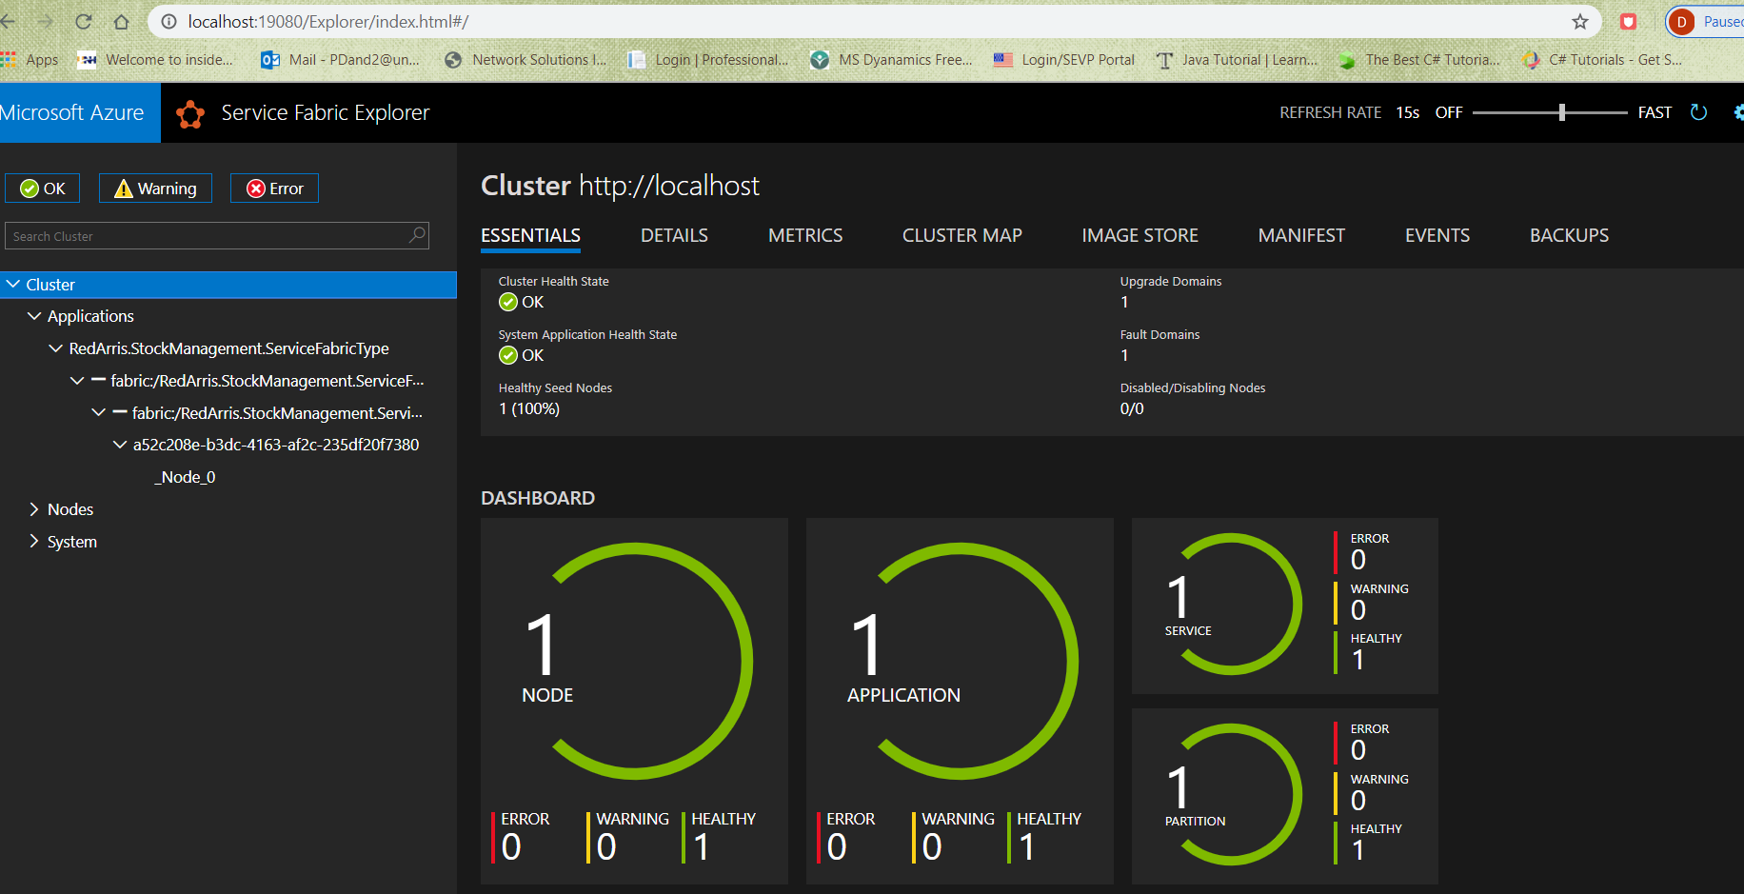

* IEX API has been consumed to get the required data.
* IEX has been treated as a repository . System can work with another repository in future(i.e. NSEStockMnagementRepository.cs). **Autofac** is used to resolve the dependency of repo, in startup.cs.

### Sample URL for GET historyData

<http://localhost:9038/api/Stockmanager/historicdata/twtr/20200406/20200408>

### Sample URL for GET Alpha

<http://localhost:9038/api/Stockmanager/alpha/twtr/twtr/20200406/20200408>

## Assumptions

* ***Instruction in the test document for HistoryData :- Calculate daily returns for the days specified***

‘Calculate’ is not well defined in the instruction. I have just taken the highest closing value for a given date.

* ***Instruction in the test document for GET Alpha:- Calculate the alpha (one number) of the ticker vs. the benchmark over the time period requested***

Calculation logic is not clear. The difference between symbol return and benchmark symbol return has been treated as Alpha, for the day.